ROLLS-ROYCE | MEDIA INFORMATION
A YEAR OF MARVELS AND MASTERPIECES:
ROLLS-ROYCE REFLECTS ON 2024 BESPOKE HIGHLIGHTS

Thursday 19 December 2024, Goodwood, West Sussex
- Landmark Bespoke commissions completed in 2024 reflect the record level of Bespoke demand
- Commissions illustrate clients’ increasingly bold, diverse and personal inspirations
- Each features unique details never previously seen in a Rolls-Royce motor car, including paint inspired by celestial phenomena and a Bespoke gold golf putter
- Testament to the exceptional creativity, skill and unparalleled artistry of the Bespoke Collective
- Highlights include all motor cars in the current Rolls-Royce product portfolio

“Every Rolls-Royce motor car serves as a blank canvas for an owner’s Bespoke commission. This year, we have once again been delighted and challenged by the breadth of our clients’ imagination, creativity and ambition, which presented the perfect opportunity to showcase the ingenuity and vision of our Bespoke Collective. As these commission highlights demonstrate, inspiration can come from anywhere, and increasingly we see clients requesting even more personal touches in their motor car, creating expressive works in their own right and as part of a broader legacy. It is a testimony to the skills of our Bespoke teams, and our brand’s standing in the luxury world, that clients share with us their dreams, confident in our ability to realise them in line with their ambitious creative vision.”
Chris Brownridge, Chief Executive, Rolls-Royce Motor Cars

In 2024, the Rolls-Royce Bespoke Collective of designers, engineers and craftspeople brought to life some of the most creative and ambitious examples of artistry ever seen.
Client commissions comprised highly complex, hand-painted and embroidered artworks, stainless steel and gold inlays, exquisite iridescent paint finishes and much more. Driven by their pursuit of perfection and the dreams of the marque’s clients, Rolls-Royce artisans created singular graphics, such as a 869,500-stitch embroidery inspired by the Spirit of Ecstasy, and captured cultural symbols using the canvas of leather, wood and fabric. From finely executed coachline motifs to full-scale artworks within the interior, the Rolls-Royce Bespoke Collective once again stretched the breadth of luxury possibility.
The extraordinary complexity behind this year’s commissions reflects the ever-growing number of clients that trust the marque’s artisans with their boldest visions. While these inspirations are as diverse as the personalities of the clients themselves, clear themes have emerged over the year. Bespoke commissions are becoming increasingly personal, with many clients curating individual masterpieces to mark major life events and commemorate transformative moments, places and people that are meaningful to them.
As 2024 comes to an end, Rolls-Royce reflects on just some of the finest examples of Bespoke possibility. The motor cars selected are owned by clients who have generously given permission for their details to be shared with the public.
 |  | PHANTOM SCINTILLA
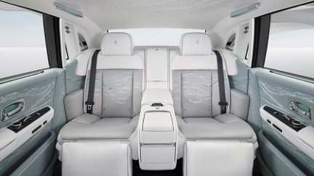  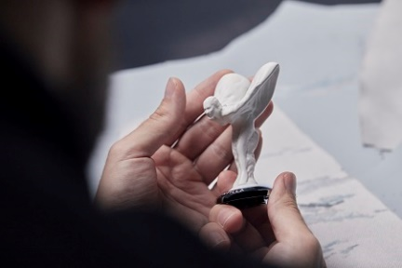  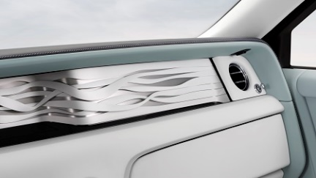 |  | Limited to just 10 examples worldwide, this magnificent Private Collection celebrates the ethereal beauty, grace and legacy of the Spirit of Ecstasy.  The interior is embroidered with 869,500 stitches forming a continuous graphic inspired by her expressive form. The figurine itself has a unique ceramic finish, evoking the Parian marble of The Winged Victory of Samothrace, the Greek statue that inspired Claude Johnson to commission the original mascot in 1910.  The centrepiece is the Celestial Pulse Gallery, capturing the fleeting presence of the Spirit of Ecstasy. This artwork comprises seven individually milled ribbons, cloaked in the same ceramic finish as the Spirit of Ecstasy figurine. Above, the Bespoke Starlight Headliner features an animation with 1,500 fibre-optic ‘stars’, inspired by the Spirit of Ecstasy’s flowing gown.
 |  | BLACK BADGE GHOST CITY LIGHTS
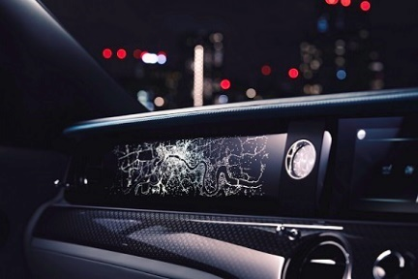 |  | In this commission, created exclusively for the UK, the Illuminated Fascia features a Bespoke design recreating a bird’s-eye panorama of London. The graphic is inspired by the thrilling view of the city seen from an aeroplane as it makes its final approach to landing at night. The pattern is composed of 8,372 laser-etched lights, each individually placed by hand in the Piano Black veneer surface.
 |  | CULLINAN SERIES II – INSPIRED BY ROSE
 | 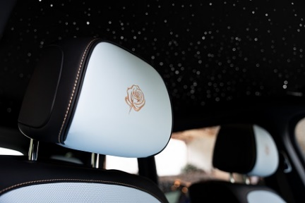  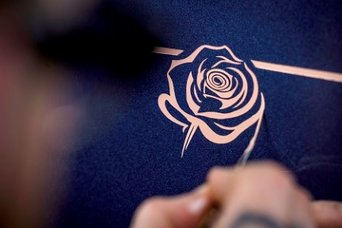 | This delicate, highly artistic commission was inspired by the Phantom Rose, specially bred for Rolls-Royce, which grows in the courtyard of the Home of Rolls-Royce at Goodwood and nowhere else in the world.  Bespoke designers created a stylised rose motif, which was then translated into the delicate embroidery on the front and rear headrests and incorporated into the meticulously hand-painted Coachline.

 | PHANTOM GOLDFINGER
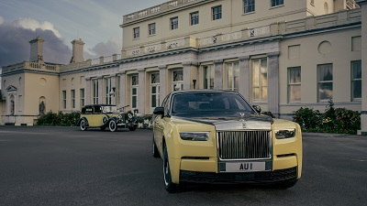  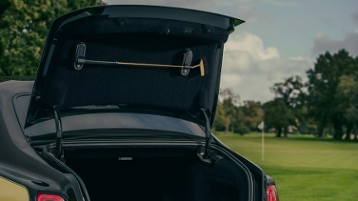  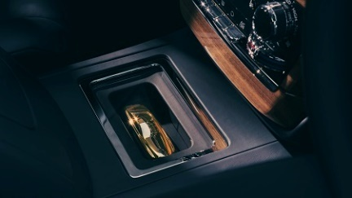  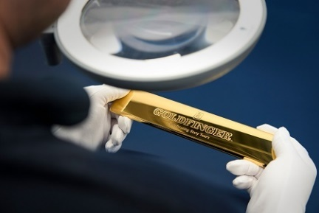  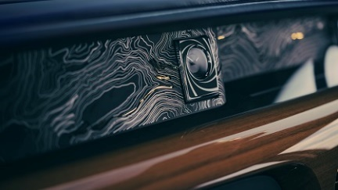 | To mark the 60th anniversary of the James Bond film Goldfinger, Rolls-Royce created this intricately detailed homage to the eponymous villain’s 1937 Phantom III Sedanca de Ville.  Bespoke specialists faithfully recreated the original motor car’s famous black and yellow exterior finish, with ingenious features referencing the film’s pivotal scenes – from a gold golf putter, inspired by one used by Auric Goldfinger in his infamous match with 007, to a solid 18-carat gold speedform displayed in the centre console.  Other gold-inspired features include gold-plated treadplates embossed with the same font developed for the film in 1964, a 24-carat gold-plated VIN plaque engraved with a number ending in 007, as well as organ stops, seat bullets and speaker frets with a lustrous gold finish.  The Gallery houses a stainless-steel artwork featuring an isoline map of the Furka Pass, where 007 is seen in the film following Goldfinger to his smelting plant. As another subtle reference, the Starlight Headliner reflects the constellations as they appeared over the Furka Pass in Switzerland on the final day of filming the scene. As a finishing touch, a hidden projector was developed to display the legendary ‘007’ logo when the boot is opened.

 | SPECTRE LUNAFLAIR
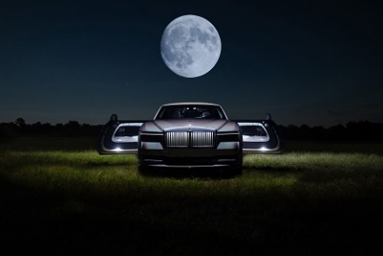  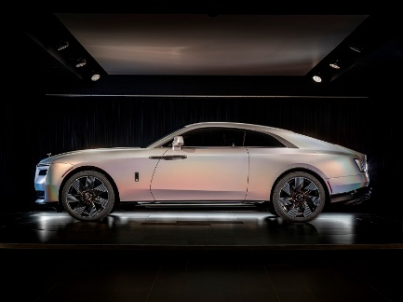  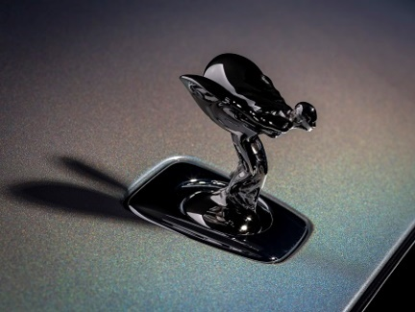 | Commissioned by a discerning client from the United States, Spectre Lunaflair draws inspiration from the optical phenomenon of a lunar halo, where moonlight refracted through high-altitude ice crystals creates a bright ring around the moon.  To capture this spectacle, the marque’s specialists spent a year developing a unique holographic paint finish, reserved exclusively for the commissioning client. The captivating ‘rainbow’ effect is achieved by applying seven layers of lacquer, including a pearlescent layer infused with fine flakes of magnesium fluoride and aluminium. This creates a deep metallic effect in low light that bursts into rainbow technicolour under bright sunshine.  The Spectre Lunaflair concept was partially inspired by another Bespoke masterpiece, the one-of-one Phantom Syntopia. Captivated by Phantom Syntopia’s iridescent Liquid Noir finish, the commissioning client asked the Bespoke Collective to create a light and luminous expression of this concept that reflected their fascination with the lunar halo phenomenon. This cross-pollination of ideas exemplifies the power of Bespoke at Rolls-Royce.
 | GHOST EXTENDED SERIES II – THE ENCOUNTER
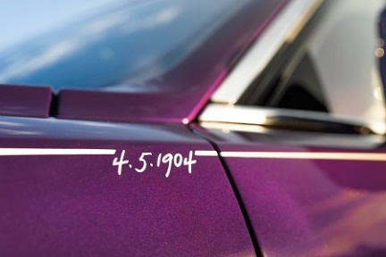  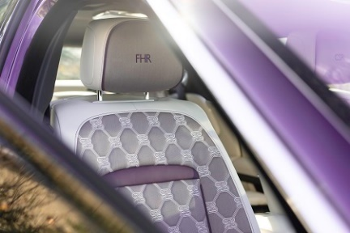 | This exquisite Ghost Extended Series II is designed to mark the 120th anniversary of the meeting of its founders on 4 May 1904. The celebratory commission contains numerous references to The Hon. Charles Stewart Rolls and Henry Royce, including their initials embroidered on the headrests, their signatures on the C-pillar, and the historic date of their introduction as the coachline motif.  The interior is finished in Duality Twill, a new rayon fabric made from bamboo, embroidered with a ‘Duality’ graphic – an abstract interpretation of the interlinked R initials of the marque’s founders’ names.
 | PHANTOM YEAR OF THE DRAGON
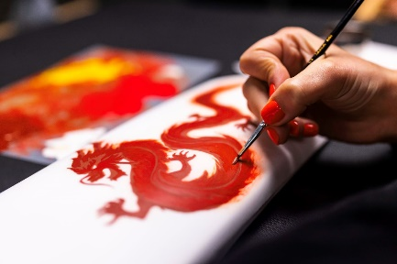  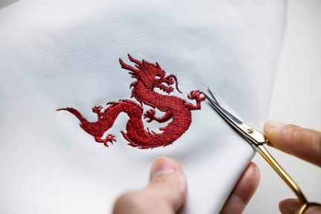  - ENDS - | Commissioned via the Shanghai Private Office, this extraordinary Phantom Extended was created to mark the Lunar New Year, beginning on 10 February 2024. In a beautiful example of the growing trend towards blending international heritage and Chinese cultural traditions, known as guochao, the interior features meticulously crafted details inspired by a traditional dragon symbol.  These include a unique hand-painted artwork on the front passenger panel, dragon embroidery on the headrests, coachline motif and the first-ever depiction of a dragon in a Bespoke Starlight Headliner, crafted from 677 ‘stars’.

TECHNICAL INFORMATION
- Black Badge Ghost: WLTP (combined) CO2 emission: 359 g/km; Fuel consumption: 17.9 mpg / 15.8 l/100km.
- Ghost Extended Series II: WLTP (combined) CO2 emission: 358-348 g/km; Fuel consumption: 17.9–18.5mpg / 15.8–15.3 l/100km.
- Spectre: WLTP: Power consumption: 2.6-2.8 mi/kWh / 23.6-22.2 kWh/100km. Electric range 329 mi / 530 km. NEDC: CO2 emissions 0 g/km.
- Phantom Series II: NEDC combined: CO2 emissions: 345 g/km; Fuel consumption: 18.7 mpg / 15.1 l/100km. WLTP combined: CO2 emissions: 351-362 g/km; Fuel consumption: 17.7-18.2 mpg / 15.5-16.0 l/100km.
- Phantom Extended Series II: NEDC combined: CO2 emissions: 345 g/km; Fuel consumption: 18.7 mpg / 15.1 l/100km. WLTP combined: CO2 emissions: 353-365 g/km; Fuel consumption: 17.4-18.1 mpg / 15.6-16.2 l/100km.
- Cullinan Series II: WLTP (combined) CO2 emission: 380-363 g/km; Fuel consumption: 16.8-17.7 mpg / 16.8-16.0 l/100km.
Further information: https://bit.ly/3XtQW7q

FURTHER INFORMATION
You can find all our press releases and press kits, as well as a wide selection of high resolution, downloadable photographs and video footage at our media website, PressClub.
You can also follow marque on social media: LinkedIn; YouTube; Instagram; and Facebook.

EDITORS’ NOTES
Rolls-Royce Motor Cars is a true luxury house, creating the world’s most recognised, revered and desirable handcrafted Bespoke products for its international clientele.
There are over 2,500 people working at the Home of Rolls-Royce at Goodwood, West Sussex. This comprises both its global headquarters and Centre of Luxury Manufacturing Excellence – the only place in the world where Rolls-Royce motor cars are designed, engineered and meticulously built by hand. An independent study by the London School of Economics & Political Science confirms that since the company first launched at Goodwood in 2003, it has contributed more than £4 billion to the UK economy and adds more than £500 million in economic value every year.
Rolls-Royce Motor Cars is a wholly owned subsidiary of the BMW Group and is a completely separate, unrelated company from Rolls-Royce plc, the manufacturer of aircraft engines and propulsion systems.

CONTACTS | GOODWOOD
Director of Global Communications  Emma Begley: +44 (0)1243 384060 Email | Head of Corporate Relations and Heritage  Andrew Ball: +44 (0)7815 244064 Email
Head of Global Product Communications  Georgina Cox: +44 (0)7815 370878 Email | Global Product PR Manager  Katie Sherman: +44 (0)7815 244896 Email
Head of Global Luxury and Corporate Communications  Marius Tegneby: +44 (0)7815 246106 Email | Sustainability and Corporate Communications Manager  Luke Strudwick: +44 (0)7815 245918 Email
Global Bespoke Communications
Malika Abdullaeva:
+44 (0)7815 244874 Email
CONTACTS | GLOBAL
The Americas  Gerry Spahn: +1 201 930 8308 Email | Asia Pacific (South) and India  Juliana Tan: +65 9695 3840 Email
Central/Eastern Europe and Central Asia  Frank Tiemann: +49 160 9697 5807 Email | Central and Western Europe  Ruth Hilse: +49 89 382 60064 Email
China  Ou Sun: +86 186 0059 0675 Email | Japan and Korea  Yuki Imamura: +81 90 5216 1957 Email
Middle East and Africa  Haya Shanata: +971 56 171 7883 Email | United Kingdom and Ireland  Isabel Matthews: +44 (0)7815 245127 Email

