ROLLS-ROYCE | MEDIA INFORMATION
THE NEW ROLLS-ROYCE GHOST ARRIVES IN UNITED KINGDOM SHOWROOMS
Thursday October 22, Goodwood, West Sussex

- First Ghost and Ghost Extended motor cars arrive in UK showrooms
- London’s Shard served as inspiration for Ghost’s ‘Post Opulent’ design philosophy

- First UK customer deliveries to take place from December 2020

“From the creation of the first Goodwood Ghost in 2009, this less formal, more dynamic expression of the marque has drawn an entirely new generation of British entrepreneurs to Rolls-Royce. We are proud to bring them the most technologically advanced Rolls-Royce yet. Ghost will continue to underpin the marque’s success in its home market by standing as the ultimate reward for the men and women who drive Britain's vibrant culture of entrepreneurship.”

Julian Jenkins, Regional Director, UK, Europe, Russia and Central Asia

The first New Rolls-Royce Ghosts have arrived in UK showrooms following a highly successful home-market debut.

After final inspection at the Home of Rolls-Royce in Goodwood, England, the motor cars were dispatched to the marque’s seven home-market dealerships; Edinburgh, Manchester, Birmingham, Essex, London, Leeds and Sunningdale.

New Ghost is the result of exhaustive dialogue with the marque’s customers. Many demanded a car that rejected unnecessary branding, affectation or obtrusive technology. In response to this, the marque’s designers immersed themselves in spaces that reflected a minimalist approach to statement design.

London played a particularly important role in defining the new Ghost’s design direction. The capital’s landmark Shard building informed the reductive approach to aesthetic form that came to be internally known as ‘Post Opulence’. Designed by Pritzker Architecture Prize winning architect Renzo Piano, the building is widely praised for its monolithic yet simple forms delivered by highly complex engineering processes. This echoes Ghost’s design and development process, where the client requirement for simplicity was delivered through cutting-edge engineering and manufacturing techniques.

First customer deliveries for Ghost and Ghost Extended will commence in late Q4 2020.

ENDS

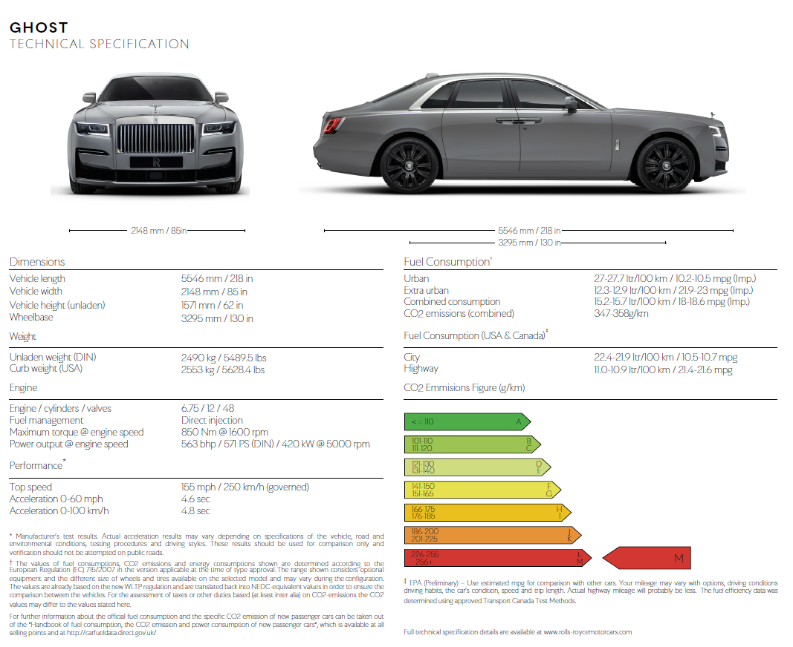
TECHNICAL SPECIFICATIONS

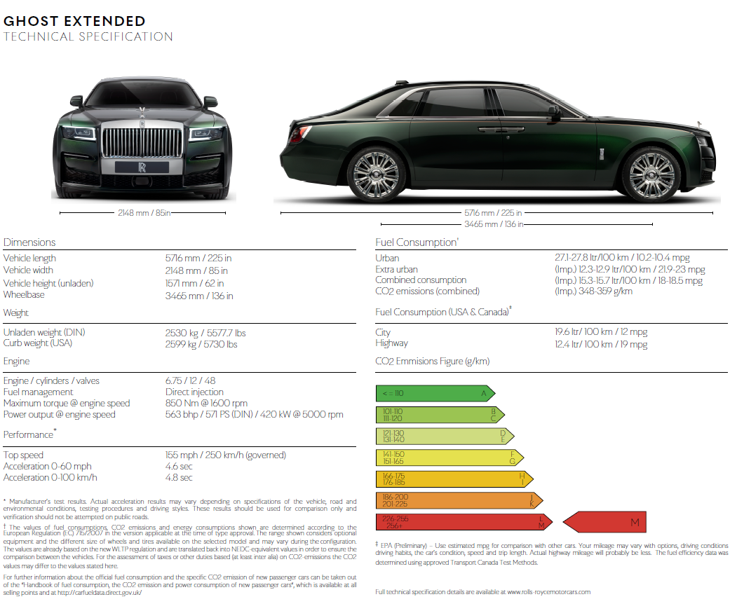

FURTHER INFORMATION
You can find all our press releases and press kits, as well as a wide selection of high resolution, downloadable photographs and video footage at our media website, PressClub.

EDITORS’ NOTES
Rolls-Royce Motor Cars is a wholly-owned subsidiary of the BMW Group and is a completely separate company from Rolls-Royce plc, the manufacturer of aircraft engines and propulsion systems. Over 2,000 skilled men and women are employed at the Rolls-Royce Motor Cars’ head office and manufacturing plant at Goodwood, West Sussex, the only place in the world where the company’s super-luxury motor cars are hand-built.

CONTACTS | Goodwood

Director of Global Communications
Richard Carter
+44 (0) 1243 384060
richard.carter@rolls-roycemotorcars.com
Head of Corporate Relations
Andrew Ball
+44 (0) 7185 244064
andrew.ball@rolls-roycemotorcars.com
Head of Corporate Relations
Emma Rickett
+44 (0) 7815 244061
emma.rickett@rolls-roycemotorcars.com
Head of Global Product Communications
Matthew Jones
+44 (0) 7815 245929
matthew.jones@rolls-roycemotorcars.com
Head of Global Digital, Online & Social PR Communications
Terence Church
+44 (0) 7815 245930
terence.church@rolls-roycemotorcars.com

CONTACTS | Regional

Asia Pacific – North
Rosemary Mitchell
+81 (0) 3 6259 8888
rosemary.mitchell@rolls-roycemotorcars.com
Asia Pacific – South
Hal Serudin
+65 8161 2843
hal.serudin@rolls-roycemotorcars.com
Central/Eastern Europe and CIS
Frank Tiemann
+49 (0) 160 9697 5807
frank.tiemann@rolls-roycemotorcars.com
Central and Western Europe
Ruth Hilse
+49 (0) 151 601 60064
ruth.hilse@rolls-roycemotorcars.com
China
Anna Xu
+86 10 84558037
anna.xu@rolls-roycemotorcars.com
Middle East and Africa
Rami Joudi
+971 56 171 7883
rami.joudi@rolls-roycemotorcars.com
Russia
Malika Abdullaeva
+7 916 449 86 22
malika.abdullaeva@press.rolls-roycemotorcars.ru
The Americas
Gerry Spahn
+1 201 930 8308
gerry.spahn@rolls-roycemotorcarsna.com

